Requirements Specification

CS 499: Senior Design

Client: eStudio

September 21, 2015

‽

Team: Students Who Understand Scrum (Kinda) (SWUSK)

Student 1: Title Page, Table of Contents, Introduction, Development and Target Environments

Student 2: Project Overview, System Model, Feasibility

Student 3 (main editor): User Interaction, Functional Requirements, Nonfunctional Requirements, Conclusion

Table of Contents

1. Introduction 3

1.1. Project Overview 3

1.2. Project Scope 3

1.3. Document Overview 3

2. Project Overview 3

2.1. Background 4

2.2. Involved Parties 4

2.3. Description of Problem 4

2.4. Features 4

2.5. Constraints 4

3. Development and Target Environments 4

3.1. Operation Environment 4

**3.1.1.** **Physical Environment** 5

**3.1.2.** **External Interfaces** 5

3.2. Resources 5

**3.2.1.** **Hardware Resources** 5

**3.2.2.** **Software Resources** 5

4. System Model 5

4.1. Components 5

**4.1.1. Phase 1 System** 5

**4.1.2. Phase 2 System** 6

5. User Interaction 6

5.1. Phase 1: Landing Page 6

**5.1.1.** **Accessing Page** 6

**5.1.2.** **Making Appointment** 6

5.2. Phase 2: Feedback App 6

**5.2.1.** **Completing Survey** 6

**5.2.2.** **Exporting Data** 7

# Introduction

## Project Overview

### The University of Kentucky eStudio has many students sign up for appointments using their booking system, Bookeo. The administrator of the eStudio, Dr. Emily Dotson, believes that the page used to display this booking system is not visually pleasing. She has instructed our team to create a visually stunning web page that reflects the professional tone of the eStudio.

### The eStudio also currently has no way to receive feedback from the students they help. Dr. Dotson would like to receive this information so that she can improve the services of the eStudio. After finishing the booking page, we have been instructed to create a feedback app for an Android tablet so that students may take a quick survey as they leave their appointments.

### Dr. Dotson places priority on the booking page part of this project. Therefore, we will refer to it as “Phase 1” for the rest of this document. The feedback app will be referred to as “Phase 2.”

## Project Scope

### For Phase 1, we must have a “visually stunning” web page that reflects the eStudio. This page must be streamlined and logically functional. It must use an editable widget from Bookeo, the current booking system used by the eStudio.

### For Phase 2, we will create an app for giving feedback to the staff of the eStudio. It must be usable on an Android Tablet. It will contain given questions written by Dr. Dotson that will be answered on a scale from 1 to 6. The eStudio must receive these scores on a regular schedule. Also, low feedback scores (1s) must be flagged and sent directly to Dr. Dotson.

## Document Overview

### This document outlines the requirements of this project. It allows our team to organize our thoughts and process so that we can insure that our client receives the product they desire. We will discuss the specific requirements of the project, the environment in which it will be used, the users, and our model for creating the project. The intended audience is our project manager, who will ensure that we are prepared to begin the project.

# Project Overview

### This section outlines the overview of our project in more detail. Here we give any background information relevant to the project, the persons and entities involved, the problem to be solved, and the main features and constraints of the project.

## Background

### The eStudio is a writing and communications help center for University of Kentucky students, primarily for College of Engineering students. As such, the need for their image to reflect the services they provide. Our client has emphasized the need for Phase 1 to be clean, “visually stunning”, and intuitive. They have no way to receive feedback to help improve their services.

## Involved Parties

### Our project is being developed for the University of Kentucky’s eStudio. The stakeholder is Dr. Emily Dotson. The eStudio staff, Dr. Dotson, and students who utilize the eStudio are users of our system.

## Description of Problem

### The eStudio is currently using a bare-bones booking web page. There is currently no feedback system in place. In Phase 1 of our project, we will develop a visually stunning web page that will utilize a widget to log appointments through Bookeo. Phase 2 will be to implement an android app that students will use to provide feedback on the way out of the eStudio. This app will email Dr. Dotson at regular intervals with the results of this feedback. Developing these will provide professional and significantly more personalized products, as opposed to using a service.

## Features

### The main features of Phase 1 will be: a clean, easy-to-use webpage that students can use to input the necessary booking information, and the web page must properly log that information with Bookeo. Phase 2 will have the following main features: an intuitive application that allows students to answer a feedback survey, the app must log that information in a database, the data must be summarized and made to highlight important feedback, and it must send this summary to Dr. Dotson on a regular schedule.

## Constraints

### Phase 1 is only limited to the extent that we are able to edit the Bookeo widget we will be working with. It will also be limited to however many browsers we can optimize it for. Phase 2 is limited in target operating system, Android.

# Development and Target Environments

### This section describes the environment in which our project will be used and what we will use to develop it. We will describe the physical area in which the project will be used, as well as the systems with which our project will interface. We will also describe the hardware and software resources needed for use, development and maintenance of the project.

## Operation Environment

### **Physical Environment**

### Phase 1 of the project will be used in a browser on any computer. Anyone who wishes to make an appointment will use the eStudio webpage to access our booking page.

### Phase 2 of the project will be used on a tablet owned by the eStudio. It will be placed near the exit so that feedback can be left after an appointment.

### **External Interfaces**

### Phase 1 must interface with Bookeo using the Bookeo widget. It will also be accessible via the eStudio website.

### Phase 2 must be able to interface with a Windows database so that we can send data to the eStudio staff.

## Resources

### **Hardware Resources**

### Phase 1 does not require any hardware resources to run. To build the system, we will need a computer with internet access.

### Phase 2 requires a working Android tablet to run. We will install our app on this tablet, which will be used by students leaving the eStudio. To build the app, we each have a computer with appropriate hardware for programming.

### **Software Resources**

### For Phase 1, a user must have a web browser that can open our webpage. To build the page, we will be using online resources. It has been requested that we host our site on SquareSpace, using a Bookeo widget.

### For Phase 2, the Android tablet must run Android OS 4.0 or later to run our application. To develop and maintain the app, we will use Eclipse with a Java IDE and JDK 1.8 installed.

# System Model

### In this section we give a high-level view of the system that shows the interactions of various parts of the system.

## Components

### **4.1.1. Phase 1 System**

### The components of Phase 1 are the webpage with a Bookeo widget and the Bookeo system. When the student enters their data, the Bookeo widget sends it to the proper Bookeo account. Bookeo logs that information. Bookeo sends confirmation that the data has been logged properly or there was an error to the webpage. The webpage then displays that information. (see appendix 10.1 for diagram)

### **4.1.2. Phase 2 System**

### The components of Phase 2 are the student user interface, the backend system, the administrator user interface, and the email location the results are sent. The student user interface accepts the data and the backend system stores it. The student user interface displays confirmation upon successfully storing the data. (see appendix 10.2 for diagram) The administrator user interface accepts login information and the backend system confirms correct login information. On success, the backend system sends the stored data to the email location. The administrator user interface displays confirmation that the data was sent successfully and prompts the user to delete the data stored locally. If approved, the backend deletes the data and the user interface displays confirmation and redirects to the main menu. (see appendix 10.3 for diagram)

# User Interaction

## Phase 1: Landing Page

### **Accessing Page**

### A student can access the web page by following a link from the University of Kentucky website or using its URL directly.

### **Making Appointment**

### A student can make an appointment after opening the web page.

### The student will navigate to the section of the page marked “Create an Appointment.”

### The student will click on the button marked with the type of appointment they would like to schedule.

### The student will be presented with an interface allowing them to choose a date and time to meet with a member of the eStudio staff.

### After choosing a date and time, Bookeo (external; outside project scope) will record the appointment.

### The student will be given confirmation of the appointment and is free to exit the page.

## Phase 2: Feedback App

### **Completing Survey**

### A student will arrive at the tablet (kiosk) to complete a feedback survey.

### The student will select “Complete feedback form” from the main menu on the kiosk.

### The student will be presented with a series of questions pertaining to the quality of their experience in the eStudio and will answer each by rating an aspect of their experience on a scale of 1-5.

### After answering the questions, the user will be asked to provide any additional comments not covered by the questions, in text form.

### Once all questions and comments are entered, the app will display a thank-you message to the user.

### **Exporting Data**

### An administrator will access the app via the same kiosk as a student.

### The administrator will select “Export Data” from the main menu.

### The app will prompt the administrator for a password.

### If the password is invalid or the app otherwise cannot verify it, it will display a message and restart the process.

### Upon successful verification, the app will connect to the internet and send all stored data to a predetermined location.

### If the app fails to connect to the internet, it will display a message on the screen indicating a connection failure and return to the main menu.

### The administrator will be asked whether the data stored in the app should be cleared.

### If the administrator selects “yes,” the app’s local memory will be cleared.

### The app will display a message to the administrator indicating that all processes are complete. The app will return to the main menu.

# Functional Requirements

### This section focuses on the primary functional requirements of each phase of the project. Each phase’s requirements are detailed individually in the subsections that follow.

## Phase 1: Landing Page

### **Appearance/Contents**

### The web page will contain the following:

### The eStudio logo

### A description of the purpose and services provided by the eStudio

### The location of the eStudio

### One or more endorsements of the eStudio from former clients

### A subsection that allows the user to book an appointment with the eStudio (see *6.1.2*).

### The above information will be formatted in an easy-to-navigate manner on a single page.

### The above information will be accompanied by images pertaining to and representing the environment and services provided by the eStudio.

### **Appointments**

### The web page will have four buttons corresponding to the four types of appointments available at the eStudio.

### Clicking any of the four buttons will open an interface for the user to create an appointment.

### This appointment creation is handled by Bookeo, and is outside the scope of this project.

## Phase 2: Feedback App

### **Question Bank**

### The app will have a pool of questions determined at creation to be used in feedback surveys.

### This functionality may be extended to allow for questions to be edited, added, or removed in future phases.

### Each question will have answers on a numeric rating scale from 1 (worst) to 5 (best).

### The question bank will also contain one question to be answered in text (“Do you have any other comments about your experience?”). This will always be the last question used.

### **Start/Idle**

### Upon opening the app or completing another task, the user will be met with a splash page.

### This page will have two options: take a survey, export data.

### Selecting one of those options will take the user to the corresponding pages, detailed in the following sections.

### **Survey**

### Upon selecting the survey option, the user will be presented immediately with a randomly selected question from the question bank.

### Each question will be presented individually on-screen (see appendix 10.4 for mockup).

### The user will be able to select any one of the five answers to the presented question by tapping them.

### When the user taps an answer, the app will record that answer and display the next question to the user.

### This process repeats for each question in the question bank.

### If the user answers with a 1 to any question, the survey is flagged for an alert (see *6.2.5*).

### The last question will be answered in text using a text box and standard Android tablet text input.

### The app will store the complete set of the user’s answers into local memory for retrieval in *6.2.4*.

### After answering the last question, the user will be shown a page thanking them for their feedback.

### Tapping anywhere on this page will return the app to the idle state (*6.2.2*).

### **Data Collection/Access**

### Upon selecting the Export Data option, the user will be presented with an authentication page.

### The user will be prompted to input a password via a text box in the center of the screen.

### This will be handled using standard Android touch-screen input.

### The app will confirm that the password is valid.

### If the device is not connected to the internet, or the app is otherwise unable to connect to verify the password, it will notify the user of the connection failure and the app will return to the idle state (*6.2.2*).

### If the password is invalid, the app will notify the user via text below the input box and prompt again for a password.

### The user will have the option in this case to return to the idle state (*6.2.2*).

### Upon password verification, the user will be able to export all locally stored survey data through e-mail.

### Data will be sent in spreadsheet format to the eStudio e-mail address (pre-set).

### The user will be given the option to clear all stored survey results after exporting.

### Once all data has been exported and the user has selected an option regarding data storage, the app will return to the idle state (*6.2.2*).

### **Alerts**

### Upon completion of a survey, the app will check for a requisite number of alert flags (default 1).

### If the requisite number of flags are found in the survey response, the app will immediately export the data from that survey response to a pre-set administrator e-mail address.

# Nonfunctional Requirements

### This section focuses on required aspects of both phases of the project that do not pertain directly to functionality. Each of the following subsections pertains to a broad type of nonfunctional requirement, with the details of how those requirements pertain to each phase detailed within.

## Compatibility

### **Landing Page**

### The landing page should be compatible with most major internet browsers such that it can load on most machines without issue.

### **Feedback App**

### The app should be capable of sending data to a Windows-based machine in a format that can be opened and processed by such a machine.

## Response Time/Speed

### **Loading Page**

### The response speed of the appointment-booking functionality is outside the scope of this project, and is handled by Bookeo.

### **Feedback App**

### The app should take no longer than one second between questions while a student is completing feedback.

# Feasibility

### In this section, we outline the worst and best case for the deliverables of our project.

## Basic/Essential Functionality Model

### At the most basic level, Phase 1 must have inputs for students to log their information and that information must be properly registered with Bookeo. It must also be visually clean. For the most simple version, Phase 2 would be an app that has a few hard coded questions that sends an excel file of the results to Dr. Dotson via email on a regular schedule.

## Full-Functionality Model

### In an optimal case, our team will spend a large portion of Phase 1 tailoring the webpage to the eStudio and making it “visually stunning”. The Bookeo widget will be customized and seamlessly integrated to the site. Phase 2 will also be “visually stunning” and, from a design perspective, feel like it belongs with phase 1. It will be able to accept more and/or different questions and perform an analysis to highlight important results of the survey. This will be sent in a well formatted email to Dr. Dotson, with the raw data attached.

# Conclusion

### The two phases of the eStudio project represent only a moderate amount of code work. However, this is supplemented by significant work pertaining to aesthetic detail, making it a well-rounded project. We believe that it is well within our team’s ability to deliver a finished project within the allotted time frame.

# Appendices

## Phase 1 System Overview

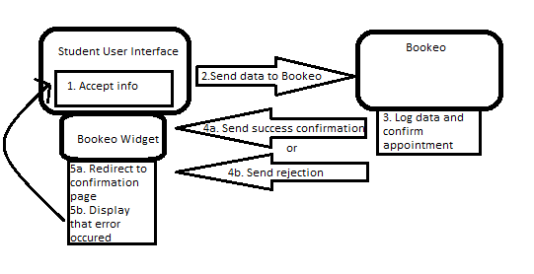

## Phase 2 System Overview - Student Use

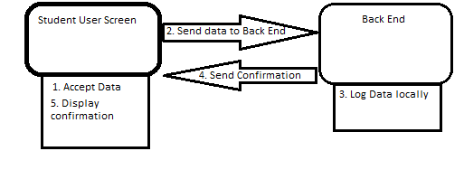

## Phase 2 System Overview - Administrator Use

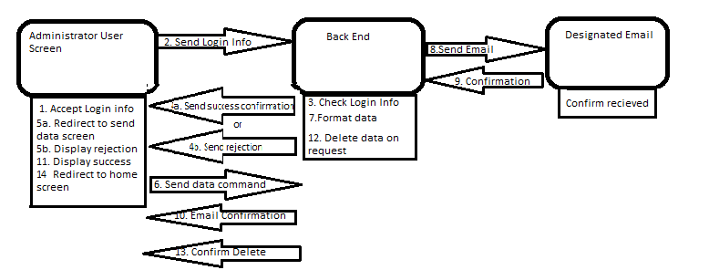

## Survey Question Mockup

